
NATIONAL TEXTILE
UNIVERSITY
DEPARTMENT OF COMPUTER SCIENCE
Subject
Operating System
SUBMITTED BY:
Fatima Waseem: 23-NTU-CS1155
SECTION SE: 5th (A)
SUBMITTED TO:
Sir Nasir

Lab 9
Binary Semaphore Example:
Code:
#include <stdio.h>
#include <pthread.h>
#include <semaphore.h>
#include <unistd.h>
sem_t mutex; // Binary semaphore
int counter = 0;
void* thread_function(void* arg) {
int id = *(int*)arg;
for (int i = 0; i < 5; i++) {
printf("Thread %d: Waiting...\n", id);
sem_wait(&mutex); // Acquire

// Critical sectionj
counter++;
printf("Thread %d: In critical section | Counter = %d\n", id,
counter);
sleep(1);
sem_post(&mutex); // Release
sleep(1);
}
return NULL;
}
int main() {
sem_init(&mutex, 0, 1); // Binary semaphore initialized to 1
pthread_t t1, t2;
int id1 = 1, id2 = 2;
pthread_create(&t1, NULL, thread_function, &id1);
pthread_create(&t2, NULL, thread_function, &id2);

pthread_join(t1, NULL);
pthread_join(t2, NULL);
printf("Final Counter Value: %d\n", counter);
sem_destroy(&mutex);
return 0;
}

Output:
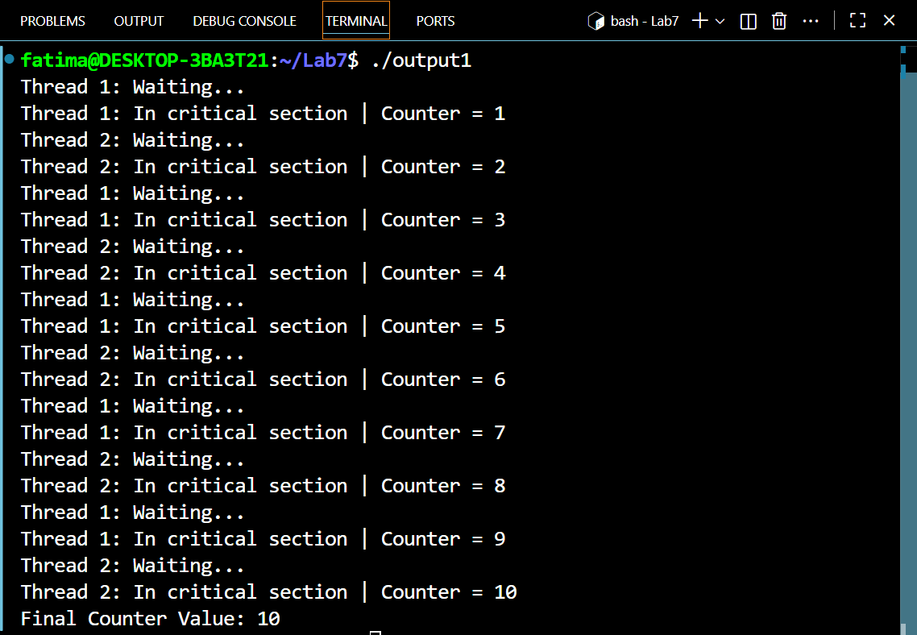

When initialized value of is 0:
#include <stdio.h>
#include <pthread.h>
#include <semaphore.h>
#include <unistd.h>
sem_t mutex; // Binary semaphore
int counter = 0;
void* thread_function(void* arg) {
int id = *(int*)arg;
for (int i = 0; i < 5; i++) {
printf("Thread %d: Waiting...\n", id);
sem_wait(&mutex); // Acquire

// Critical sectionj
counter++;
printf("Thread %d: In critical section | Counter = %d\n", id,
counter);
sleep(1);
sem_post(&mutex); // Release
sleep(1);
}
return NULL;
}
int main() {
sem_init(&mutex, 0, 0); // Binary semaphore initialized to 1
pthread_t t1, t2;
int id1 = 1, id2 = 2;
pthread_create(&t1, NULL, thread_function, &id1);
pthread_create(&t2, NULL, thread_function, &id2);

pthread_join(t1, NULL);
pthread_join(t2, NULL);
printf("Final Counter Value: %d\n", counter);
sem_destroy(&mutex);
return 0;
}

Output:
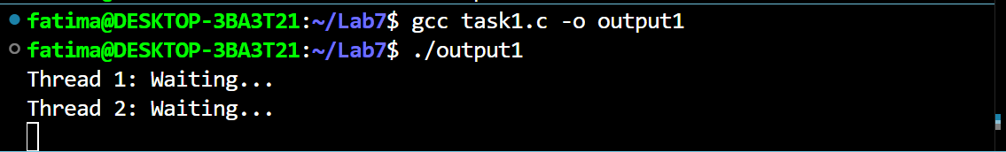
Explanation:
It will be block because all threads wants to enter critical section no thread can enter the critical section.
When sem_post(&mutex) will be commented:
#include <stdio.h>
#include <pthread.h>
#include <semaphore.h>
#include <unistd.h>
sem_t mutex; // Binary semaphore
int counter = 0;
void* thread_function(void* arg) {
int id = *(int*)arg;
for (int i = 0; i < 5; i++) {
printf("Thread %d: Waiting...\n", id);
sem_wait(&mutex); // Acquire

// Critical sectionj
counter++;
printf("Thread %d: In critical section | Counter = %d\n", id,
counter);
sleep(1);
//sem_post(&mutex); // Release
sleep(1);
}
return NULL;
}
int main() {
sem_init(&mutex, 0, 1); // Binary semaphore initialized to 1
pthread_t t1, t2;
int id1 = 1, id2 = 2;
pthread_create(&t1, NULL, thread_function, &id1);
pthread_create(&t2, NULL, thread_function, &id2);

pthread_join(t1, NULL);
pthread_join(t2, NULL);
printf("Final Counter Value: %d\n", counter);
sem_destroy(&mutex);
return 0;
}

Output:
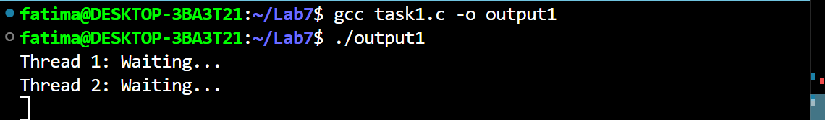

Explanation:
In this code the first thread will not release forever, and thread will remain blocked forever.

When we will comment out the sem_wait():
Code:
#include <stdio.h>
#include <pthread.h>
#include <semaphore.h>
#include <unistd.h>
sem_t mutex; // Binary semaphore
int counter = 0;
void* thread_function(void* arg) {
int id = *(int*)arg;
for (int i = 0; i < 5; i++) {
printf("Thread %d: Waiting...\n", id);
//sem_wait(&mutex); // Acquire

// Critical sectionj
counter++;
printf("Thread %d: In critical section | Counter = %d\n", id,
counter);
sleep(1);
sem_post(&mutex); // Release
sleep(1);
}
return NULL;
}
int main() {
sem_init(&mutex, 0, 1); // Binary semaphore initialized to 1
pthread_t t1, t2;
int id1 = 1, id2 = 2;
pthread_create(&t1, NULL, thread_function, &id1);
pthread_create(&t2, NULL, thread_function, &id2);

pthread_join(t1, NULL);
pthread_join(t2, NULL);
printf("Final Counter Value: %d\n", counter);
sem_destroy(&mutex);
return 0;
}

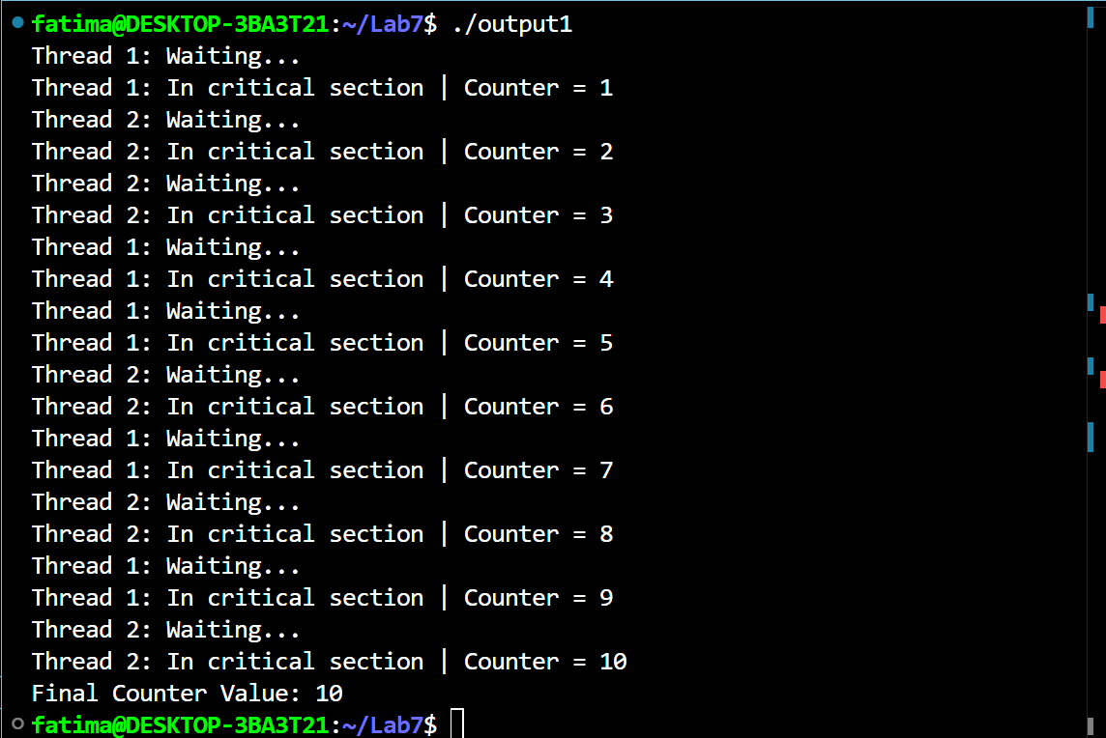
Output:
Explanation:
All threads will enter the critical section without checking the semaphore all threads will enter the critical section at the same time. There is no blocking or mutual exclusion.
Task2:
Code:
#include <stdio.h>
#include <pthread.h>
#include <semaphore.h>
#include <unistd.h>
sem_t mutex; // Binary semaphore
int counter = 0;

void* producer(void* arg) {
int id = *(int*)arg;
for (int i = 0; i < 5; i++) {
printf("Thread %d: Waiting...\n", id);
sem_wait(&mutex); // Acquire

// Critical sectionj
counter++;
printf("Thread %d: In critical section | Counter = %d\n", id,
counter);
sleep(1);
sem_post(&mutex); // Release
sleep(1);
}
return NULL;
}

void* consumer(void* arg) {
int id = *(int*)arg;
for (int i = 0; i < 5; i++) {
printf("Thread %d: Waiting...\n", id);
sem_wait(&mutex); // Acquire

// Critical sectionj
counter--;
printf("Thread %d: In critical section | Counter = %d\n", id,
counter);
sleep(1);
sem_post(&mutex); // Release
sleep(1);
}
return NULL;
}

int main() {
sem_init(&mutex, 0, 1); // Binary semaphore initialized to 1
pthread_t t1, t2;
int id1 = 1, id2 = 2;
pthread_create(&t1, NULL, producer, &id1);
pthread_create(&t2, NULL, consumer, &id2);

pthread_join(t1, NULL);
pthread_join(t2, NULL);
printf("Final Counter Value: %d\n", counter);
sem_destroy(&mutex);
return 0;
}

Output:

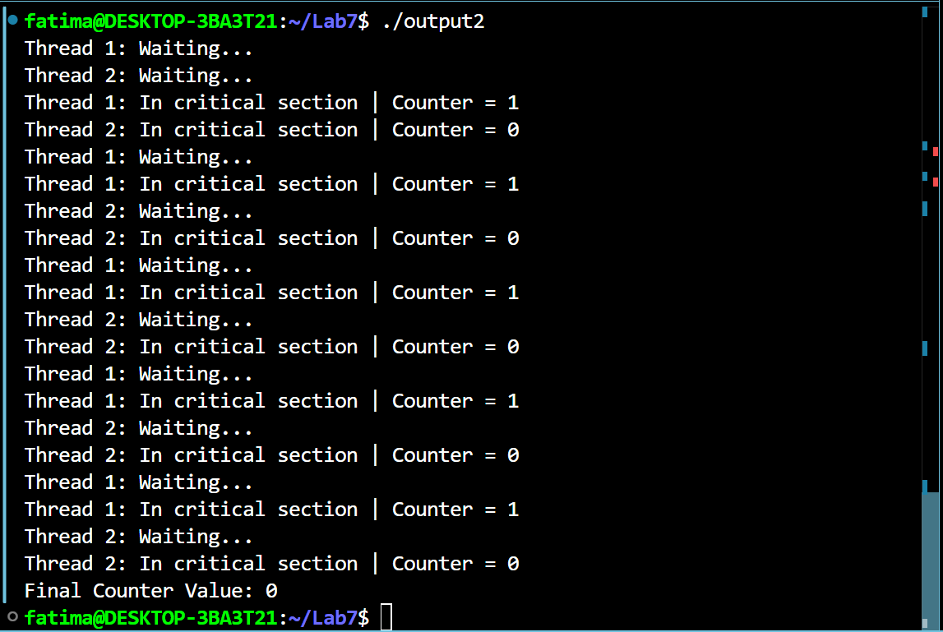
When semaphore is initialized to zero:
#include <stdio.h>
#include <pthread.h>
#include <semaphore.h>
#include <unistd.h>
sem_t mutex; // Binary semaphore
int counter = 0;

void* producer(void* arg) {
int id = *(int*)arg;
for (int i = 0; i < 5; i++) {
printf("Thread %d: Waiting...\n", id);
sem_wait(&mutex); // Acquire

// Critical sectionj
counter++;
printf("Thread %d: In critical section | Counter = %d\n", id,
counter);
sleep(1);
sem_post(&mutex); // Release
sleep(1);
}
return NULL;
}

void* consumer(void* arg) {
int id = *(int*)arg;
for (int i = 0; i < 5; i++) {
printf("Thread %d: Waiting...\n", id);
sem_wait(&mutex); // Acquire

// Critical sectionj
counter--;
printf("Thread %d: In critical section | Counter = %d\n", id,
counter);
sleep(1);
sem_post(&mutex); // Release
sleep(1);
}
return NULL;
}

int main() {
sem_init(&mutex, 0, 0); // Binary semaphore initialized to 1
pthread_t t1, t2;
int id1 = 1, id2 = 2;
pthread_create(&t1, NULL, producer, &id1);
pthread_create(&t2, NULL, consumer, &id2);

pthread_join(t1, NULL);
pthread_join(t2, NULL);
printf("Final Counter Value: %d\n", counter);
sem_destroy(&mutex);
return 0;
}

Output:
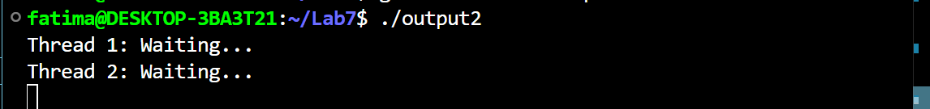
Explanation:
It will be block because all threads wants to enter critical section no thread can enter the critical section.
When sem_post () will be commented:
Code:
#include <stdio.h>
#include <pthread.h>
#include <semaphore.h>
#include <unistd.h>
sem_t mutex; // Binary semaphore
int counter = 0;

void* producer(void* arg) {
int id = *(int*)arg;
for (int i = 0; i < 5; i++) {
printf("Thread %d: Waiting...\n", id);
sem_wait(&mutex); // Acquire

// Critical sectionj
counter++;
printf("Thread %d: In critical section | Counter = %d\n", id,
counter);
sleep(1);
sem_post(&mutex); // Release
sleep(1);
}
return NULL;
}

void* consumer(void* arg) {
int id = *(int*)arg;
for (int i = 0; i < 5; i++) {
printf("Thread %d: Waiting...\n", id);
sem_wait(&mutex); // Acquire

// Critical sectionj
counter--;
printf("Thread %d: In critical section | Counter = %d\n", id,
counter);
sleep(1);
//sem_post(&mutex); // Release
sleep(1);
}
return NULL;
}

int main() {
sem_init(&mutex, 0, 1); // Binary semaphore initialized to 1
pthread_t t1, t2;
int id1 = 1, id2 = 2;
pthread_create(&t1, NULL, producer, &id1);
pthread_create(&t2, NULL, consumer, &id2);

pthread_join(t1, NULL);
pthread_join(t2, NULL);
printf("Final Counter Value: %d\n", counter);
sem_destroy(&mutex);
return 0;
}

Output:
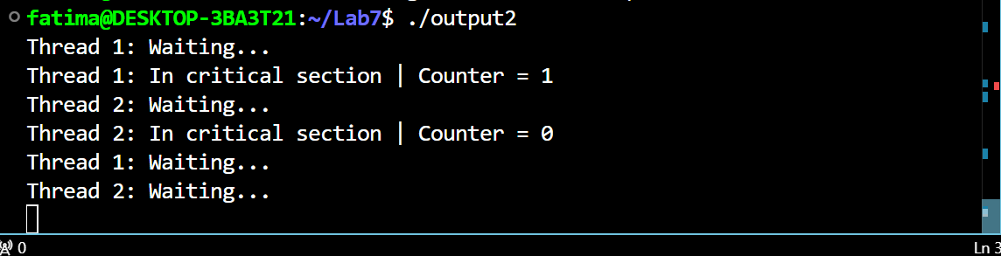
Explanation:
Starting threads will not release forever so it will blocked all other threads.

When sem_wait() will be commented:
#include <stdio.h>
#include <pthread.h>
#include <semaphore.h>
#include <unistd.h>
sem_t mutex; // Binary semaphore
int counter = 0;

void* producer(void* arg) {
int id = *(int*)arg;
for (int i = 0; i < 5; i++) {
printf("Thread %d: Waiting...\n", id);
sem_wait(&mutex); // Acquire

// Critical sectionj
counter++;
printf("Thread %d: In critical section | Counter = %d\n", id,
counter);
sleep(1);
sem_post(&mutex); // Release
sleep(1);
}
return NULL;
}

void* consumer(void* arg) {
int id = *(int*)arg;
for (int i = 0; i < 5; i++) {
printf("Thread %d: Waiting...\n", id);
//sem_wait(&mutex); // Acquire

// Critical sectionj
counter--;
printf("Thread %d: In critical section | Counter = %d\n", id,
counter);
sleep(1);
sem_post(&mutex); // Release
sleep(1);
}
return NULL;
}

int main() {
sem_init(&mutex, 0, 1); // Binary semaphore initialized to 1
pthread_t t1, t2;
int id1 = 1, id2 = 2;
pthread_create(&t1, NULL, producer, &id1);
pthread_create(&t2, NULL, consumer, &id2);

pthread_join(t1, NULL);
pthread_join(t2, NULL);
printf("Final Counter Value: %d\n", counter);
sem_destroy(&mutex);
return 0;
}

Output:
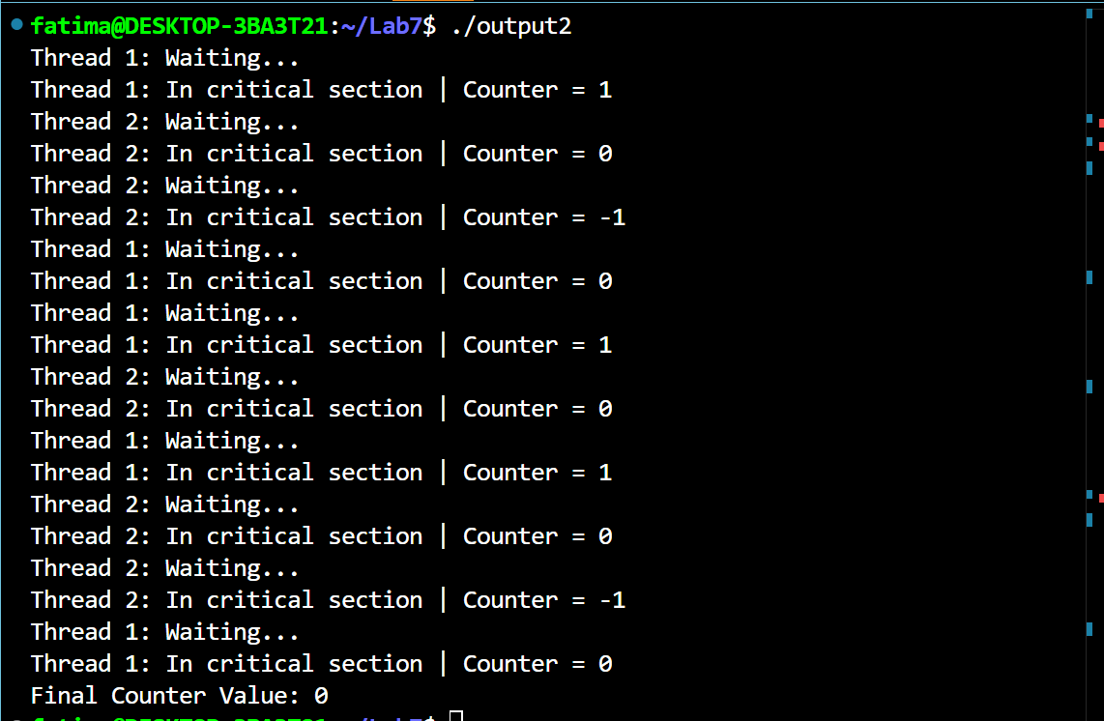
Explanation:
All threads will enter the critical section without checking the semaphore all threads will enter the critical section at the same time. There is no blocking or mutual exclusion.

Task3:
Similarities and differences of binary semaphore and mutex lock.
Differences:
Semaphore | Mutex
Its functions based on signaling mechanism. | It functions based on locking mechanisms.
Multiple threads can acquire semaphore at a time concurrently. | Only one thread can acquire mutex at a time.
It has no ownership. | It has ownership because only owner can release the lock.
It has lower deadlock risk. | It has higher deadlock risk if one thread forgets to unlock.
Similarities:
Used in multithreading.
They protect the critical section.
Control access to resources.
Can be 0/1 locked/unlocked.

